What to choose now

AgentCore + MCP is great for tool management. Step Functions is great for workflow correctness. In lending, workflow correctness is the non-negotiable requirement.”

We can use AgentCore Gateway/MCP for tool standardization, but Step Functions should still own the lending workflow.

1) Why Java (team strength → delivery speed)
- Fastest delivery comes from the team’s strongest stack. If everyone is strongest in Java/Kotlin, we’ll ship faster and with fewer defects than forcing Python.
- Shared libraries and patterns already exist (logging, validation, HTTP clients, security, error handling). Reuse beats re-learning.
- Better maintainability long-term: the same devs will own this when it grows; Java/Kotlin reduces “bus factor”.
- Consistency across services/tools: tool Lambdas, domain models, error contracts can be shared cleanly.
Short line: “Choosing Java is a delivery and ownership decision, not a language preference.”

2) Why Step Functions instead of MCP for orchestration
- Step Functions is a workflow engine. MCP isn’t. MCP standardizes tool interfaces; it doesn’t give deterministic orchestration, retries, waits, or execution history.
- Lending needs stateful, auditable, long-running flows (docs upload, e-sign, underwriting). Step Functions supports this natively.
- If we orchestrate via an MCP gateway, we will rebuild workflow features in code (state store, timers/waits, retries, compensation, audit trail).
- Step Functions keeps the process deterministic and reduces risk from LLM non-determinism.
Short line: “MCP can help define tools; Step Functions should own the lending workflow.”

3) Why Lambda orchestrator instead of AgentCore (for now)
- Prototype speed: Lambda is the quickest path to a working end-to-end MVP with minimal platform adoption.
- We keep the orchestrator thin: Bedrock call + session in DynamoDB + start/advance Step Functions. The heavy work is in Step Functions + tool Lambdas.
- Avoid committing early to a new platform layer. AgentCore may be good, but adopting it is a bigger architectural dependency; we can evaluate after proving the flow.
- Clear migration path: if latency/complexity grows, we can move the agent layer to Spring Boot (ECS/EC2) later without changing Step Functions or tools.
Short line: “Lambda is the lowest-friction entry point; Step Functions keeps us from building a custom platform.”

A strong closing statement
- “We’re optimizing for a fast, safe prototype: Java for delivery speed, Step Functions for workflow correctness, and a thin Lambda agent layer we can replace later if needed. MCP is optional as a tool catalog, but not our orchestration engine.”

The Engine API can be our source of truth for business state, but Bedrock is stateless. Without a small conversation memory store, the agent cannot resume a conversation coherently when a user returns. We don’t need a full DB—just a lightweight session store to reconstruct conversational context.

You can propose this:
- Engine API = authoritative business state
- Step Functions = workflow execution
- DynamoDB (small table) = conversational memory only
- TTL-based so it auto-expires
- No PII, no documents, no business decisions

We’re not duplicating business data. We’re storing just enough conversational memory so the LLM can behave consistently across sessions. The Engine remains the source of truth.

- Ask chat to replicate a full conversation – what happens, where do we store stuff etc

Engine is an integration. For a prototype that may change vendors, we keep a minimal normalized application state and document status in DynamoDB, plus short conversation memory. That lets us swap engines without rewriting the whole user journey.

DB Design – to expand a bit

The key idea
Treat your Engine/3rd party as an integration, not your source of truth (at least for a prototype that may pivot).
So you keep your own minimal canonical loan/application state in DynamoDB, and you sync/push to whatever Engine exists today.
That gives you:
- continuity if Engine changes
- ability to replay/resume workflows
- consistent UI experience
- safe idempotency + audit-lite even in prototype

Should session state and loan state be in the same DynamoDB table?
It can help if you do a single-table design: fewer tables, simpler permissions, easier queries for “user → current application → status + last chat summary”.
But don’t mix them as random attributes on one item. Use separate item types (Session vs Application vs Document) within the same table.

What should be “our state” vs “engine state”
Keep in your DynamoDB (canonical for prototype)
- applicationId + userId
- current step/phase (APPLICATION / CREDIT / DOCUMENTS / OFFER / PAYOUT)
- status (IN_PROGRESS / WAITING_DOCS / REFERRED / APPROVED / REJECTED / PAID_OUT)
- references to external calls (engine IDs, decision IDs, envelope IDs)
- required docs list + upload statuses
- idempotency keys for each major action
- timestamps, last error summary, last successful state transition
- conversation summary (short), last intent, last assistant action
Keep in Engine (or 3rd party)
- detailed credit response payloads (if sensitive/large)
- full underwriting details
- their internal objects (cases, offers, etc.)
In DynamoDB, store only IDs/references + normalized status.

DynamoDB schema idea (single-table, practical)
Table: LendingState
Primary key
- PK: USER#<userId>
- SK: a typed sort key so you can store multiple items per user
Item types you’ll store
- Session
- SK: SESSION#<sessionId>
- Fields: activeApplicationId, conversationSummary, workflowExecutionArn, lastIntent, ttl, updatedAt
- Application
- SK: APP#<applicationId>
- Fields:
  - status, phase, createdAt, updatedAt
  - engineApplicationId (optional)
  - offerId, decisionId, underwriterCaseId, esignEnvelopeId
  - requiredDocs (small list or store separately as items)
  - lastErrorCode, lastErrorMessage (short), lastTransition
- Document
- SK: DOC#<applicationId>#<docType> (e.g., DOC#app123#PAYSLIP)
- Fields: s3Key, uploadStatus, verifiedStatus, checksum, uploadedAt, verifiedAt
- Idempotency / action ledger
- SK: ACT#<applicationId>#<action>#<idempotencyKey>
- Fields: resultRef, createdAt, ttl
- Purpose: prevents double-submit when retries happen
Helpful indexes (GSIs)
- GSI1: find applications by status for ops/debug
  - GSI1PK: STATUS#<status>
  - GSI1SK: UPDATED#<updatedAt>#APP#<applicationId>
- GSI2: look up by applicationId fast (when you don’t have userId)
  - GSI2PK: APP#<applicationId>
  - GSI2SK: USER#<userId>
This is enough for a prototype and still scales.

Example items (illustrative)
Session item
- PK: USER#u123
- SK: SESSION#s456
- activeApplicationId: app789
- conversationSummary: "Customer confirmed amount 10k, waiting for payslip upload."
- workflowExecutionArn: arn:aws:states:...
- lastIntent: UPLOAD_DOCS
- ttl: <epoch+30days>
- updatedAt: 2026-01-25T09:10:00Z
Application item
- PK: USER#u123
- SK: APP#app789
- phase: DOCUMENTS
- status: WAITING_DOCS
- engineApplicationId: ENG-4455 (optional)
- decisionId: DEC-9911
- offerId: OFF-2233
- updatedAt: ...
Document item
- PK: USER#u123
- SK: DOC#app789#PAYSLIP
- s3Key: docs/u123/app789/payslip.pdf
- uploadStatus: UPLOADED
- verifiedStatus: PENDING

How this helps you if the 3rd party changes
If you swap the Engine:
- your UI and agent still rely on your own normalized status/phase
- your Step Functions can be updated to call new tool Lambdas
- you can “re-sync” external IDs as needed
- you have a consistent record of where the user is
This reduces vendor lock-in and keeps your prototype from being brittle.

One strong line for architects
“Engine is an integration. For a prototype that may change vendors, we keep a minimal normalized application state and document status in DynamoDB, plus short conversation memory. That lets us swap engines without rewriting the whole user journey.”
If you want, I can also propose:
- a super-minimal version of this schema (even fewer item types), or
- how Step Functions states should read/write these items cleanly (what each step owns).

In DynamoDB, SK stands for Sort Key. It is the second part of a Composite Primary Key (which consists of a Partition Key and a Sort Key).
While the Partition Key determines the physical location (partition) where your data is stored, the Sort Key determines how that data is organized within that partition.

Key Roles of a Sort Key
- Uniqueness: In a table with a composite key, multiple items can have the same Partition Key (PK), but they must have different Sort Keys (SK). The combination of PK + SK creates a unique identifier for the item.
- Ordering: DynamoDB physically stores items with the same Partition Key together, ordered by their Sort Key values. By default, this order is ascending.
- Efficient Querying: You can use the SK to perform "range" queries. Instead of just looking up a single item, you can use operators like:
  - begins_with()
  - between
  - > , < , >= , <=

Common Use Cases
- One-to-Many Relationships: For example, in an Orders table, the CustomerID could be the PK, and the OrderDate could be the SK. This allows you to quickly query "all orders for Customer X placed in the last 30 days."
- Single-Table Design: Developers often use generic names like PK and SK (rather than specific names like UserID or OrderID) to store different types of data in the same table. For instance:
  - User Item: PK: USER#123, SK: METADATA#123
  - Order Item: PK: USER#123, SK: ORDER#2024-01-01
- Hierarchical Data: You can model hierarchies by prefixing the SK, such as COUNTRY#STATE#CITY. You can then query all items in a specific country using begins_with(COUNTRY#).

Summary Comparison
Feature | Partition Key (PK) | Sort Key (SK)
Also Known As | Hash Key | Range Key
Requirement | Mandatory | Optional
Querying | Must be an exact match (=) | Supports range comparisons (begins_with, between, etc.)
Physical Storage | Determines the partition | Determines the order within the partition
Would you like me to help you design a schema for a specific use case using PKs and SKs?

Great instinct 👍
Designing a single-table DynamoDB model from day one is often safer if you understand how it works conceptually. I’ll explain it step-by-step, comparing it directly to SQL thinking, using your lending app as the concrete example.
No buzzwords, no magic — just how it actually works.

1️⃣ First: how single-table DynamoDB really works
SQL mindset
- One table per entity
- Relations via foreign keys
- Queries assembled with JOINs
DynamoDB single-table mindset
- One table per domain
- Many item types in the same table
- Relations encoded in keys, not joins
- You query by access pattern, not by entity
Think of it as “denormalized rows grouped by partition key”.

2️⃣ The core rule (this replaces JOINs)
In a single-table design:
Everything you want to fetch together lives under the same partition key.
For your app, the natural partition key is:
PK = USER#<userId>
That means:
- session
- loan applications
- documents
- actions
all live in one logical bucket per user.

3️⃣ SQL model vs DynamoDB single-table (side-by-side)
SQL version (mental model)
users
└── applications
└── documents
To get “user + current application + docs”:
SELECT *
FROM users u
JOIN applications a ON a.user_id = u.id
JOIN documents d ON d.application_id = a.id
WHERE u.id = ?

DynamoDB single-table version
One table: LendingState
Keys
PK = USER#<userId>
SK = <ITEM_TYPE>#<ID>
You fetch everything for a user with:
Query PK = USER#<userId>
No joins. One request.

4️⃣ Item types (this replaces tables)
You store different item types in the same table.
1️⃣ Session item
{
"PK": "USER#u123",
"SK": "SESSION#s456",
"activeApplicationId": "app789",
"conversationSummary": "Waiting for payslip upload",
"workflowExecutionArn": "arn:...",
"lastIntent": "UPLOAD_DOCS",
"ttl": 1717000000
}
SQL equivalent: sessions table row

2️⃣ Application item
{
"PK": "USER#u123",
"SK": "APP#app789",
"status": "WAITING_DOCS",
"phase": "DOCUMENTS",
"engineApplicationId": "ENG-9911",
"updatedAt": "2026-01-25T10:00:00Z"
}
SQL equivalent: applications table row

3️⃣ Document item
{
"PK": "USER#u123",
"SK": "DOC#app789#PAYSLIP",
"s3Key": "docs/u123/app789/payslip.pdf",
"uploadStatus": "UPLOADED",
"verifiedStatus": "PENDING"
}
SQL equivalent: documents table row

4️⃣ Action / idempotency item
{
"PK": "USER#u123",
"SK": "ACT#app789#SUBMIT_APPLICATION#idem-001",
"result": "SUCCESS",
"ttl": 1717003600
}
SQL equivalent: actions / idempotency table

5️⃣ How queries replace JOINs
SQL: get user’s current application
SELECT *
FROM applications
WHERE user_id = 'u123'
ORDER BY updated_at DESC
LIMIT 1;
DynamoDB
Query PK = USER#u123
Filter SK begins_with "APP#"
Sort order comes from SK.

SQL: list documents for application
SELECT *
FROM documents
WHERE application_id = 'app789';
DynamoDB
Query PK = USER#u123
Filter SK begins_with "DOC#app789#"

6️⃣ Why this is safe long-term
✔ No vendor lock-in to Engine API
- You own normalized loan state
- Engine IDs are references, not dependencies
✔ Perfect fit for Step Functions
- Each step reads/writes specific item types
- No complex joins inside Lambdas
✔ Fast reads
- One query = everything needed for UI or agent context
✔ Easy TTL cleanup
- Sessions/actions auto-expire
- Applications stay

7️⃣ Tradeoffs (be honest)
- You must design keys upfront
- You can’t query arbitrarily
- Relationships are enforced by code, not DB
But in return:
- simpler runtime
- predictable performance
- fewer moving parts

8️⃣ When this beats SQL (your case)
Single-table DynamoDB is ideal when:
- access patterns are known (they are)
- most reads are “by user”
- joins are predictable
- write volume > query flexibility
That’s exactly your lending flow.

9️⃣ One sentence you can reuse
“In DynamoDB single-table design, we replace joins with carefully designed keys so that everything needed for a user lives under one partition key.”

If you want, next I can:
- draw the exact Query/Put patterns per Step Functions step, or
- show how to evolve this table when you add documents later without breaking anything.

Q&A – Converge

- Can we get access to the repo’s for the react app, lambda orchestrator and so on ?
- Did you use StepFunctions as orchestrator or the Lambda had a built-in workflow logic?
- So from my understanding, there is a react app created by the savings team within the Converge namespace; as well as a lambda that is handling authentication using Cognito; besides the access that would be very nice to get so we can have a look at these, is someone from the team that can help us with a walkthrough of what was built?
- Will we get access to AWS services and platform team support from Converge? I am asking because we might need some support setting up some of the services and I know that platform team had some automations already done. Now, we’ll most probably have some custom setup which we may need to do before doing that.
- Did you use multiple environments like dev, qa, int, prod for the cards AI app ?
- Can we get access to the Cognito user pool so we can try out the card app ourselves?
- I may still have access since I worked on the Converge services for the DOP flow 2 years ago, I have access to the repo

Platform team ? maybe / call Bob when getting to Terraform )
Envs? – only dev now

Need to have a product selected in Engine
LLM integration – has sessionId / userId
Short term memory (10 min chat) / Long term memory (1 week)

Filter by some attrib ( need to store in DB the state of )
AgentCore Runtime with LLM – like lambdas

https://github.com/Deloitte-ConvergeProsperity/ngbp-ai-core
NGBP Dev
914640637175
https://fabric-platform.awsapps.com/start/#/?tab=accounts
What solutions do we have with java? To build and deploy
Long term memory vs storing state in db. To read on this.

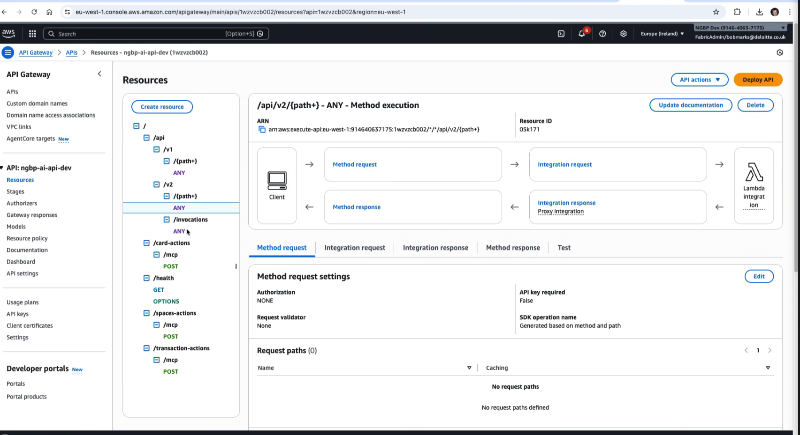

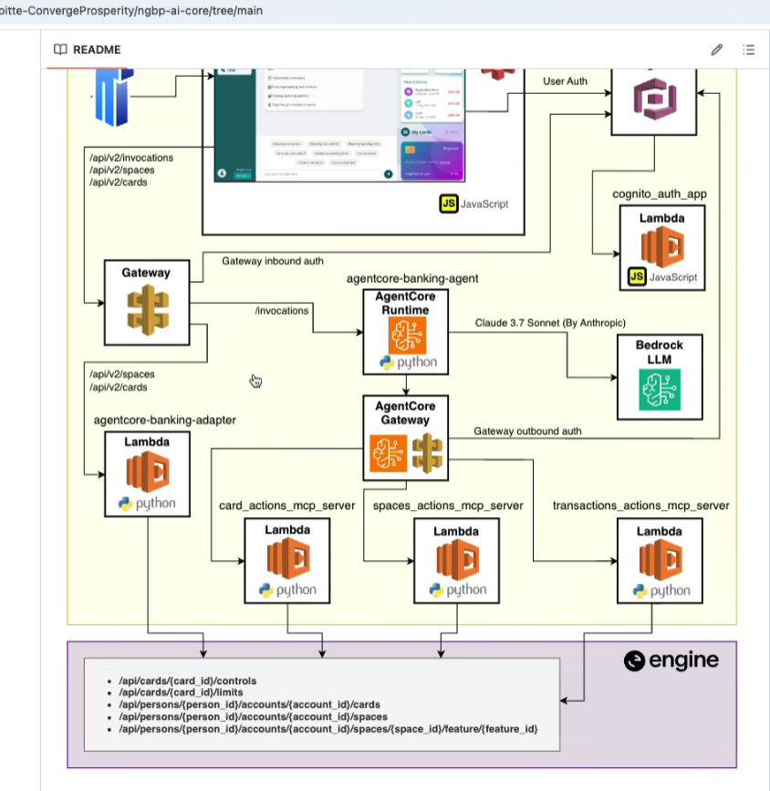

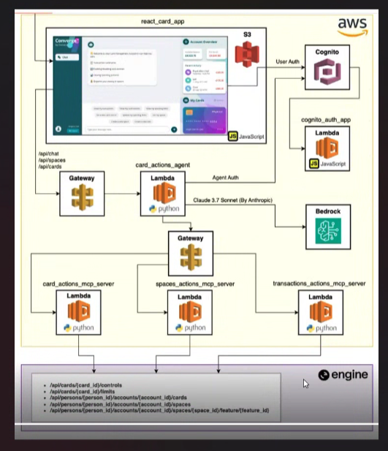

Architecture Meeting prep :

Start :
The plan is to build an LLM-powered lending interface, but I think we need to deliberately separate conversation from process execution / workflow of our needed steps.
From my point of view, the best way to achieve this for a prototype that will probably scale is having an the LLM that handles dialogue and data collection along with the AWS Step Functions that own the lending workflow.

Architecture summary (what we chose)
- React Lending App
  - Reuses existing Cognito auth
  - Acts as the conversational UI and document upload entry point
- Agent Gateway (Java Lambda)
  - Main conversational entry point
  - Integrates with AWS Bedrock for dialogue
  - Persists conversation/session state in DynamoDB
  - Starts or advances Step Functions executions
  - Keeps orchestration logic thin on purpose
- AWS Step Functions
  - Orchestrates the lending workflow:
    - Loan Application
    - Credit Assessment
    - Document Management
  - Handles branching, retries, waits, and long-running steps
  - Provides execution history and auditability
- Tool Lambdas (Java)
  - Small, single-responsibility functions
  - Call Engine / bank APIs
  - Persist outcomes and references in DynamoDB and S3
- MCP Tool Registry (optional)
  - Used only for tool definition/consistency if needed
  - Not on the critical runtime path

Why this design (the “why”, clearly stated)
1. We want the fastest safe prototype
- Lambda + Step Functions let us move quickly
- No servers to manage
- The single concern would be that lambdas have occasional cold starts or some latency variance; this should not be a problem if we do not have high traffic
- The Agent layer stays thin and replaceable
“This lets us validate the lending flow and agent behaviour quickly, without overcommitting to infrastructure.”

2. We do not want to re-implement workflow engines
- Lending is:
  - multi-step
  - stateful
  - long-running (docs, underwriting, e-sign)
- Step Functions already gives us:
  - state management
  - retries and timeouts
  - wait/callback patterns
  - execution history
“Putting orchestration logic in Lambdas or an MCP gateway would mean rebuilding workflow semantics ourselves.”

3. LLMs should not own business-critical flow
- Bedrock is non-deterministic by nature
- Lending workflows must be:
  - deterministic
  - auditable
  - repeatable
So:
- LLM = conversation & explanation
- Step Functions = process control
“The model talks to the user; the workflow decides what actually happens.”

4. Clean separation of responsibilities
- Agent Lambda:
  - dialogue
  - validation
  - session state
- Step Functions:
  - sequence
  - branching
  - waits
- Tool Lambdas:
  - integrations only
This keeps each layer simple and testable.

5. Migration path is intentionally open
- If the Agent Gateway grows:
  - we can migrate it to Spring Boot on EC2/ECS
  - without changing UI, Step Functions, or tool Lambdas
- Step Functions and tool boundaries remain stable
“We’re optimizing for learning now, without blocking a more traditional service later.”

Why not MCP gateway as the orchestrator
“MCP is useful for standardizing tool definitions, but it is not a workflow engine.”
- MCP does not provide:
  - long-running state
  - wait/resume semantics
  - retries/catch/compensation
  - execution timelines
- Using MCP as the orchestrator would push us to:
  - store state manually
  - manage retries manually
  - rebuild audit semantics
That’s exactly what Step Functions already solves.

Why DynamoDB and S3 here
- DynamoDB
  - session ↔ workflow mapping
  - application status
  - decision outcomes
  - document status
  - idempotency keys
- S3
  - uploaded documents
  - large artifacts
  - optional transcripts
“Structured state goes to DynamoDB; large or binary data goes to S3.”

One-sentence summary (strong close)
“This design lets us prototype quickly with Lambdas and Bedrock, keeps lending workflows deterministic and auditable via Step Functions, and leaves us a clean migration path to Spring Boot if and when the agent layer grows.”

AWS Step Functions vs MCP Server in LLM Lending app context

Step Functions and an MCP server solve different problems.
In the lending flow, Step Functions solves the hard problem (deterministic orchestration + state + audit).
An MCP server mostly solves tool standardization / invocation plumbing.
Bedrock doesn’t change that—if anything, it makes deterministic orchestration more important.

What Step Functions are for (process engine)
Use Step Functions when you need:
- Deterministic sequencing of steps (A → B → C)
- Branching with clear rules (underwriter path, rejection path)
- Long-running waits (docs upload, e-sign callback, underwriting decision)
- Retries/timeouts per step
- Execution history / audit trail
- Idempotent replays and recovery
That is exactly your domain: application → risk/pricing → docs/e-sign, with real waiting points.

What an MCP server gateway is for (tool gateway / tool contract)
Use an MCP server when you need:
- A standardized way for the agent to discover tools
- A consistent schema for inputs/outputs
- Centralized enforcement like:
  - “only allow these tools”
  - “these scopes can call these tools”
- A single “tool endpoint” for the agent
But it does not inherently provide:
- workflow state machine semantics
- long-running orchestration
- retries/catch/compensation semantics
- a built-in audit trail of process transitions
Unless you re-implement those in the MCP server—at which point you’ve basically built a workflow engine yourself.

The key difference (the one-liner)
Step Functions = workflow correctness and lifecycle. MCP server = tool invocation interface.
If you use MCP server instead of Step Functions for orchestration, you’ll end up recreating Step Functions features in your own code.

Why Step Functions is the better “orchestration core” here
1) Lending workflow must be deterministic (LLM must not be)
Bedrock/LLM can:
- guide the user
- collect missing info
- explain outcomes
But the actual process should be deterministic:
- what gets submitted, when
- when to branch to underwriting
- what constitutes “complete documents”
- what the retry policy is
Step Functions enforces that determinism and keeps the LLM out of the critical path.
2) Long-running steps are unavoidable
Docs and e-sign are classic async/callback flows. Underwriting can be hours/days.
- Step Functions handles wait + resume cleanly (callbacks/polling)
- MCP server would need a DB + timers + resumption logic + idempotency rules
3) Audit and traceability are built-in
- Step Functions provides an execution timeline per application.
- An MCP server can log, but then you’re building an audit-grade process history yourself (and you’ll argue about “is it complete?”).
4) Built-in error handling beats custom glue
- Step-level retries, backoff, catch, compensation are native in Step Functions.
- MCP server orchestration means you implement these patterns per tool/flow.
5) Least-power principle for safety
You can lock it down so:
- Agent service can only trigger Step Functions
- Step Functions can only call approved tool Lambdas
Even if the LLM hallucinates a tool, it can’t execute it.
With MCP server as orchestrator, you often centralize too much power into one component.

Where Bedrock fits (and why it strengthens the Step Functions case)
Because you’re using Bedrock, you’ll have:
- non-deterministic outputs (language model behavior)
- prompt/version changes over time
- model upgrades
That’s normal—but it’s exactly why you want:
- a deterministic workflow engine
- strict policies around tool execution
- a clear audit trail independent of the model
So the argument becomes:
“Bedrock handles conversation; Step Functions ensures the lending process remains deterministic, testable, and auditable.”

Short comparison between Step functions and MCP server as orchestration:

Step Functions as orchestration (recommended)
- ✅ State + long-running execution
- ✅ Deterministic branching
- ✅ Retries/timeouts/catch
- ✅ Audit trail per execution
- ✅ Visual debugging of where the process is
- ✅ Strong IAM boundary between agent and tools
MCP server as orchestration (not recommended for lending)
- ✅ Tool standardization/discovery
- ✅ Central place to enforce tool allowlists/scopes
- ❌ Workflow state machine must be custom-built
- ❌ Wait/resume/callback handling must be custom-built
- ❌ Retries/catch/compensation must be custom-built
- ❌ Audit trail becomes “our logs” (harder to defend)

The best compromise (if we need to insist on MCP)
Use both, but for the right roles:
- Bedrock: conversational reasoning
- Step Functions: orchestration + lifecycle + audit
- MCP registry: tool schemas + allowlist + classifications (read/write/PII)
- Tool Lambdas: integrations
And keep MCP out of the runtime critical path unless there’s a strong governance reason.

One meeting-ready sentence

“MCP helps us standardize tools, but Step Functions is the process engine we need for a lending workflow—stateful, auditable, and long-running. If we orchestrate via an MCP server, we’ll rebuild workflow semantics ourselves.”

Choosing between Lambda vs Microservice app for the orchestration layer

What we need this layer to do
- Authenticate user (Cognito JWT)
- Call Bedrock for dialogue
- Maintain conversation/session state (user returns later)
- Start/advance Step Functions
- Enforce policy (what actions are allowed)

Conversation state will almost certainly be DynamoDB (fast key/value, TTL, easy scaling).
S3 is usually only for large blobs (attachments, transcripts, uploaded docs), not for normal chat state.

Option 1: Java Lambda (Agent Gateway Lambda)
Pros
- Fast to ship (no servers)
- Auto-scale and cheap-ish at low usage
- Easy integration with AWS services (Bedrock, DynamoDB, Step Functions) via AWS SDK
- Good match if traffic is bursty and you keep requests short
- Probably a bit cheaper than app deployed on EC2/ECS because of the always on cost
Cons
- Cold starts / latency variance (especially Java + VPC)
- Less natural “service structure” unless you build it yourself (you can, but you’re writing your own lightweight framework)
- Harder local debugging compared to a full Spring app (still doable)
- Lambda constraints influence design:
  - max execution duration
  - payload size
  - concurrency spikes can stress downstreams
“Can Lambda use DB models, helper classes, services?”
Yes. You can structure a Java Lambda like a normal app:
- domain models (POJOs), service classes, repositories, validators
- even dependency injection (Dagger/Guice/Spring Cloud Function), though keep it light
- DynamoDB access via AWS SDK Enhanced Client or DynamoDB Mapper-like patterns
The tradeoff: you don’t get Spring Boot’s full ecosystem “for free” unless you bring it in (which can worsen cold starts).

Option 2: Spring Boot microservice (Agent Service on EC2 or ECS)
Pros
- Predictable latency (no cold starts) → better chat UX
- Best developer experience:
  - clean layering (controllers/services/repos)
  - validation, security, config, testing
  - structured logging/tracing, metrics
- Easier to implement and evolve:
  - policy enforcement
  - feature flags / A/B prompts
  - richer session logic
- Better fit if this “agent layer” will grow into a real product component
Cons
- You operate a runtime, so no serverless:
  - EC2: patching, scaling, AMIs
  - ECS: container pipeline + service management (less ops than EC2)
- Always-on cost (usually fine for B2B)
- If you’re not disciplined, it can become a “god service” (keep workflow in Step Functions)

Conversation state: DynamoDB vs S3 (quick guidance)
DynamoDB (likely yes)
Use for:
- userId/sessionId -> conversation summary + current workflow execution ARN + last step
- TTL for expiring sessions
- small structured data (few KB to maybe tens of KB)
S3 (maybe later)
Use for:
- large transcripts (if you store full chat history)
- uploaded documents (definitely)
- artifacts (PDFs, evidence files)
- anything big or binary
In most cases: DynamoDB for state, S3 for blobs.

Which should we pick?
Pick Lambda agent if:
- you want the fastest prototype
- traffic is low and you can tolerate occasional cold starts
- the agent layer stays thin (auth + Bedrock + start Step Functions + read/write DynamoDB)
Pick Spring Boot agent service if:
- you want the best UX (consistent latency)
- you expect the agent layer to grow (policy, richer logic, analytics, experimentation)
- you want easiest debugging/testing and maintainability
My default for “prototype that will grow”: Spring Boot service (EC2 is OK if your platform is EC2-first; ECS is cleaner if available).
My default for “prototype-only / thin layer”: Lambda.

A simple hybrid we can propose (very defensible)
- Start with Lambda agent for quick MVP
- Store session state in DynamoDB from day 1
- Keep tool calls behind Step Functions from day 1
- If cold starts or complexity become pain, migrate the agent endpoint to Spring Boot later (the rest stays the same)
This migration is realistic because the contracts remain:
- UI → Agent API
- Agent API → Bedrock + DynamoDB + Step Functions

How do we model Step Functions and lambdas in our actual prototype / proposed stated?

We can model the 3 high-level phases as one Lambda each, but I wouldn’t make each phase a single “big Lambda” unless you’re very sure the internals won’t grow. A better pattern is:
- Step Functions = orchestration (3 phases)
- Each phase = one or more tool Lambdas (small, single-responsibility)
- DynamoDB/S3 = persistence for state and documents
Quick recommendation
- Prototype: 3 “phase Lambdas” is acceptable if you keep them clean and short.
- Grow-ready: keep the Step Functions phase states, but split tool Lambdas by action (submit, score, create case, send e-sign).

Can the 3 phases be 3 Lambdas?
✅ Works if you do this
- Each phase Lambda is an orchestrator for that phase (calls Engine APIs, writes state)
- You enforce idempotency (retries won’t double-submit)
- You keep payload sizes reasonable, and avoid long waits inside Lambda
⚠️ Risks
- They become “mini-monolith Lambdas” as requirements grow (more rules, more integrations, more branching)
- Harder to reuse actions across phases (e.g., “retrieve customer data” used in multiple places)
- More blast radius when changing one Lambda

Better decomposition (still simple)
Use Step Functions with 3 top-level states, but inside each state call multiple tool Lambdas:
1) Loan application
- GetExistingCustomerData (Engine API)
- ValidateAndAssembleApplication (policy/validation)
- SubmitToOrigination (external API)
- PersistApplicationSnapshot (DynamoDB/S3 pointer)
2) Credit assessment
- SubmitRiskScoring (risk engine)
- SubmitPricing (pricing)
- Choice state: NeedsUnderwriter?
  - if yes: CreateUnderwriterCase + WaitForDecision (callback/event)
- PersistDecisionOutcome (DynamoDB)
3) Document management
- DetermineRequiredDocuments (rules)
- CreateUploadRequests (pre-signed S3 URLs)
- WaitForUploadComplete (event/callback)
- SendForESignature (e-sign API)
- WaitForESignComplete (event/callback)
- PersistDocumentStatus (DynamoDB + S3 refs)
This stays readable and scales better.

What interacts with DynamoDB vs S3 (and why)
DynamoDB (structured state, fast reads)
Use DynamoDB for workflow + conversation + statuses:
- Session ↔ workflow mapping
  - userId/sessionId → stepFunctionExecutionArn
- Application state
  - current phase, missing fields, last action, timestamps
- Decision state
  - risk score reference, pricing reference, underwriter status
- Document state
  - required docs list, upload statuses, e-sign envelope ID, signed status
- Idempotency keys
  - prevent duplicate submissions on retries (critical)
Why DynamoDB:
- low-latency, simple key access
- TTL for expiring sessions
- great for “status dashboards”
S3 (large objects / files / transcripts)
Use S3 for:
- Uploaded documents
- Optional: full chat transcripts (if they get big)
- Optional: request/response payload archives (for audit, if needed)
- Any “binary or large JSON” that shouldn’t live in Step Functions/DynamoDB
Typical pattern:
- DynamoDB stores metadata + S3 key, not the file itself.

Other AWS components you’ll likely need
EventBridge / SQS (asynchronous events)
For “wait and resume” patterns:
- doc upload complete (from your upload service / S3 event)
- e-sign webhook received
- underwriter decision available
Step Functions can wait for a callback or you can drive state via events.
Secrets Manager / Parameter Store
- API keys, certificates, endpoints for Engine / bank APIs
CloudWatch + X-Ray/OTel
- tracing across Agent → Step Functions → tool Lambdas → external APIs

Practical answer to your exact question
Could each phase be a single Lambda that calls Engine/bank APIs and stores state?
Yes. For a first cut, that’s reasonable.
What would it store?
- DynamoDB: “where am I in the phase, what’s done, what’s pending, references/IDs”
- S3: documents + optionally large transcripts
What should not be stored where?
- Don’t store documents in DynamoDB.
- Don’t store lots of PII or huge payloads in Step Functions state/history.

If you want a very clean starting point
Step Functions with 3 phases, each phase calls 2–4 tool Lambdas, plus DynamoDB for state and S3 for docs.
That gives you prototype speed and doesn’t trap you later.
If you want, tell me: are underwriting and e-sign handled via webhooks from vendors? If yes, I’ll outline the exact “wait/resume” wiring (EventBridge/SQS + Step Functions callback token pattern).

